Things I have done:
- App: add tab Issue year
Conclusion:
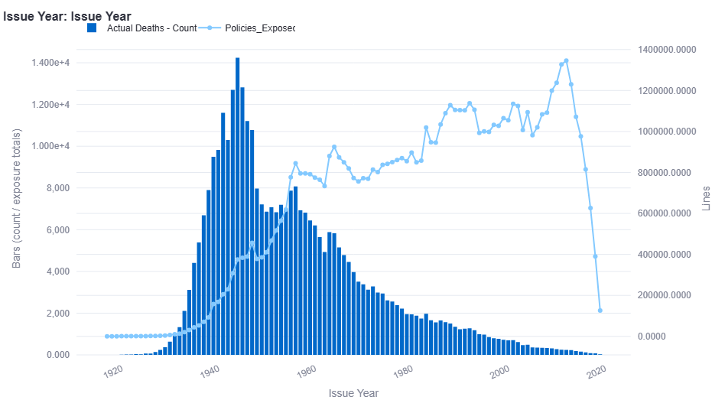
2012 – 2019 issue exposure drop: linear, scale-up!

- S/U
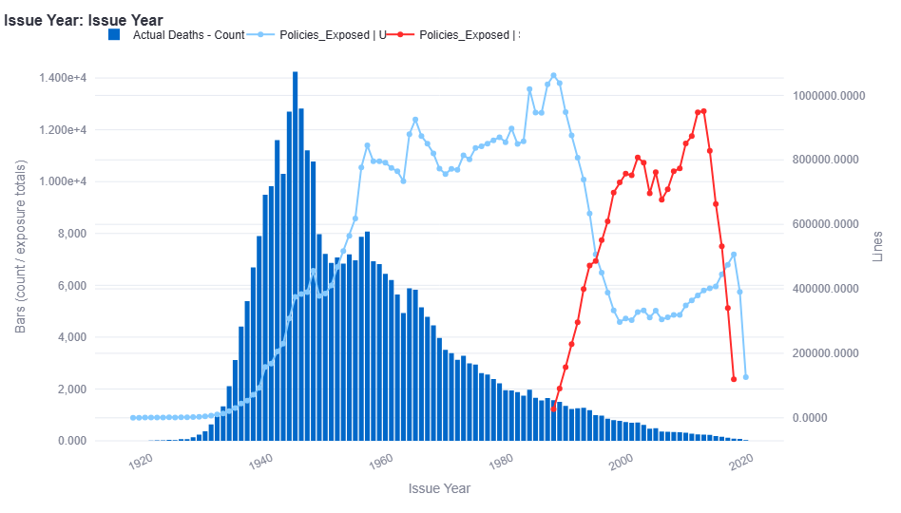
Select: <= 25 year
There should be no select period: indicator mess-up? Will include data
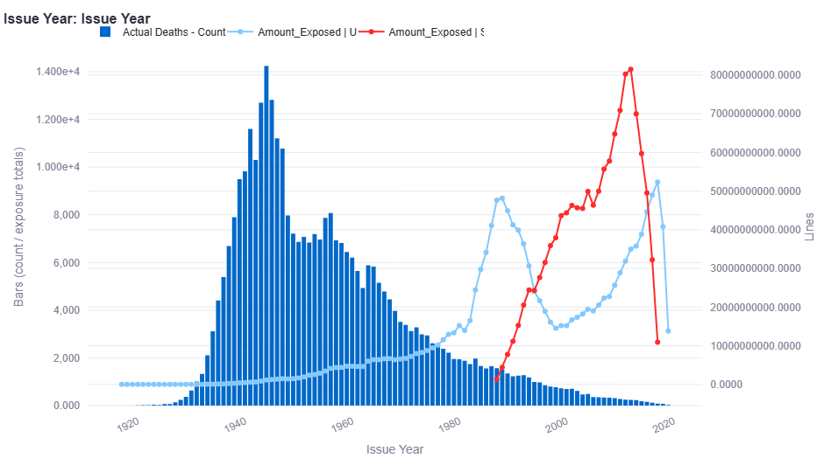
- ANB/ALB
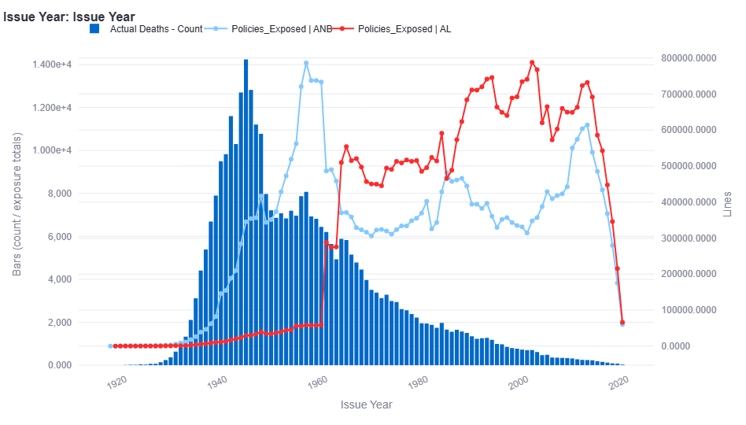
Slightly support convert to ALB
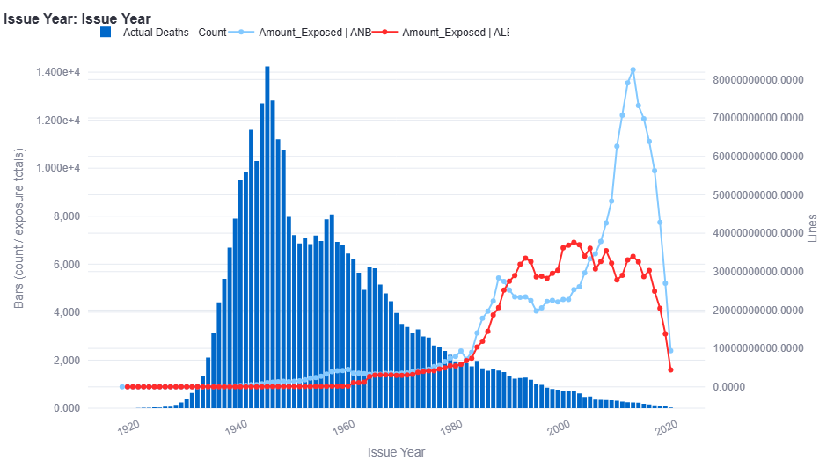
Slightly support convert to ANB

- Insurance Plan
Term unimportant by exposure count and amount, term has anti-selection? No, UL younger attained age! Build term???
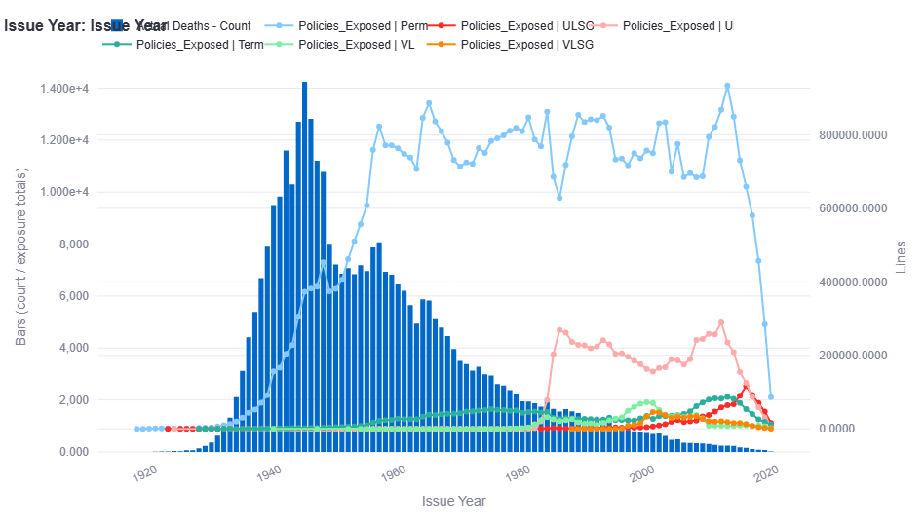
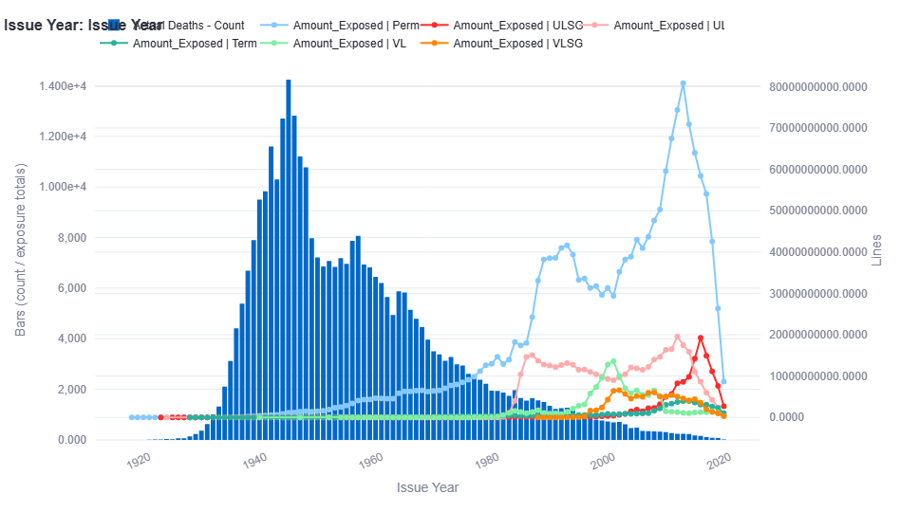
- Face Amount band
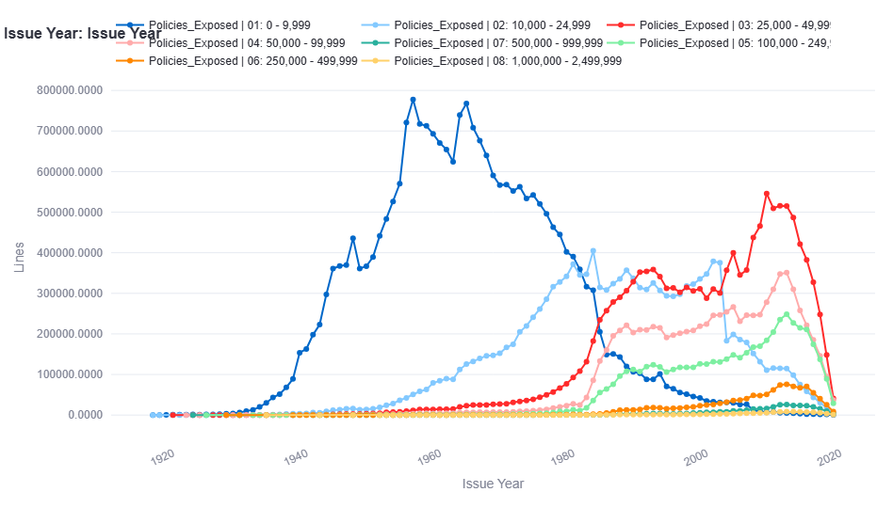
25,000 or less: less important
how to incorporate this? 03, 04, 05, 06
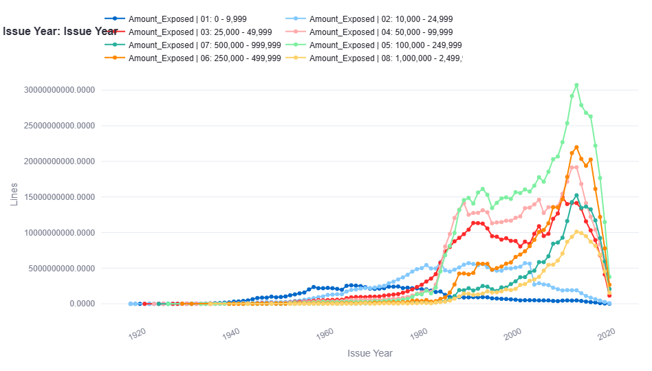

- ALB and ANB treatment
Issue_Age_mod = Issue_Age + 0.5 for ALB
Issue_Age_mod = Issue_Age for ANB
Attained_Age_mod = Attained_Age + 0.5 for ALB
Attained_Age_mod = Attained_Age for ANB

- Other lab changes:
Started model numbering 1A, 1B, …
Actual vs. Predicted graph
Heatmap coloring issue

Questions:
- Issue year conclusions
- ALB and ANB treatment
- Model steps

Model GAM-1 core
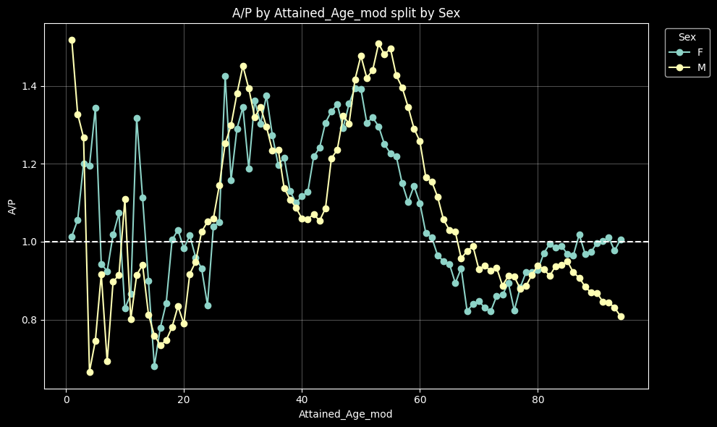
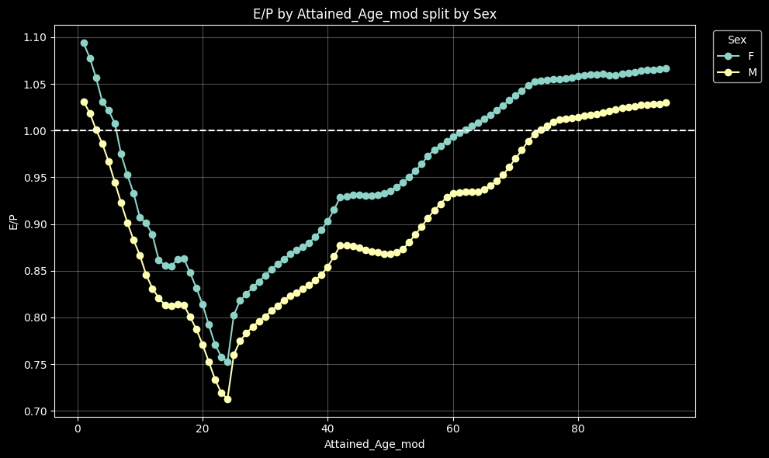

Model GAM-2 attained age
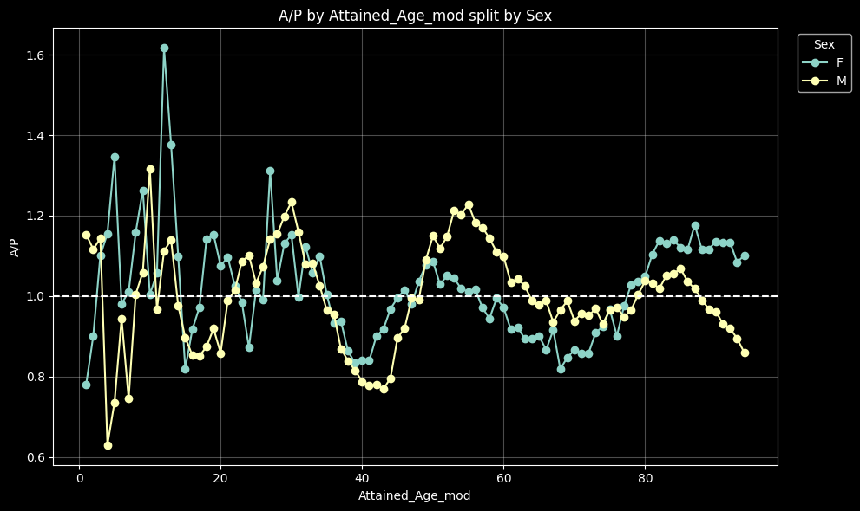
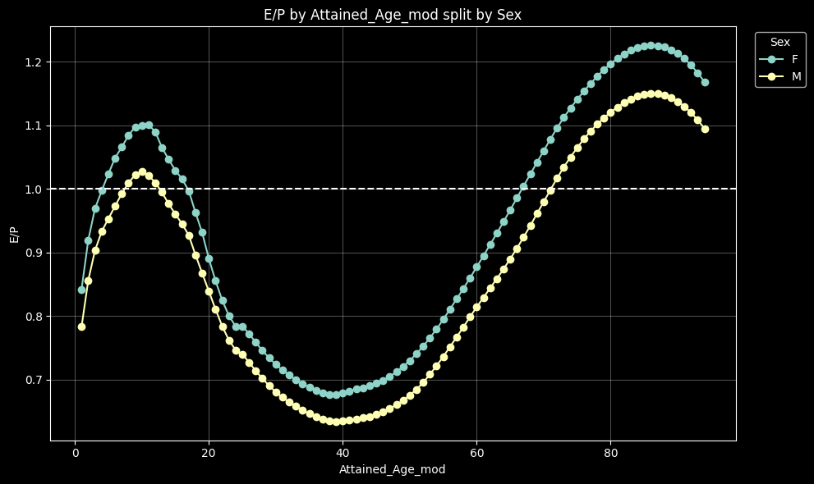

Decision level | Primary lever focus | Frontier interpretation
1 | Static baseline / compliance setup | Simple starting point, but economically inefficient
2 | Reinvestment strategy refinement | First practical move toward efficiency
3 | Asset-liability management tuning | Better balance of reserve relief and defensibility
4 | Stochastic scenario set optimization | Improves tail measurement; often a frontier candidate
5 | Hedging program integration | Strong economic benefit, but more operational complexity
6 | Reinsurance / capital optimization + product redesign | Frontier endpoint: maximum efficiency, maximum governance demand

2015 VBT
Variables Used
The juvenile subgroup used only attained age as the modeling variable — they explicitly rejected a select-and-ultimate structure (i.e., no issue age or duration variables) because no credible evidence of select mortality patterns was found in the data. The final recommendation was attained-age-only rates for juveniles, ages 0–17.
How Breakpoints Were Chosen
There was no formal statistical criterion for the duration 6 breakpoint — it appears to have been chosen by judgment as a rough midpoint to split "early" vs. "later" durations, primarily as a diagnostic tool rather than a modeling decision. The team was essentially testing whether any meaningful split existed, not optimizing a specific threshold.
Comparison to Young Adults
A key validation step was comparing juvenile results to issue ages 18–24 (Charts 5.12–5.15), which showed a clear select pattern in young adults. The contrast between the two groups confirmed to the team that juveniles behave differently and that no duration-based structure was warranted for them.
Remaining Caveat
The one unresolved question the team flagged was whether ultimate-period rates (duration 26+) for older juvenile issue ages might need some smoothing into adult rates — but they deferred that to the graduation subgroup rather than resolving it in the juvenile analysis itself.

For the ultimate data graduation, two sub-models were fit with a specific age breakpoint:
- Attained age 35 and under: juvenile issue age GAM model used
- Attained age 45 and over: adult issue age GAM model used
- Attained ages 35–45: the two models were connected by log-linear interpolation
Attained age 0 was also treated as a hard exclusion from the juvenile GAM model and handled separately to avoid smoothing anomalies.
Put more knots where the curve moves fast, fewer where it's flat.

Model 4 — Plan/Face Challenger (poisson_gam_plan_face)
Adds plan and face groupings on top of Model 3:
Categorical factors:
- Age_Ind
- Sex
- Insurance_Plan_Group (grouped: Perm / Term / Other)
- Face_Band_Group (grouped: <100k / 100k-999k / 1M+)
Continuous splines: Same
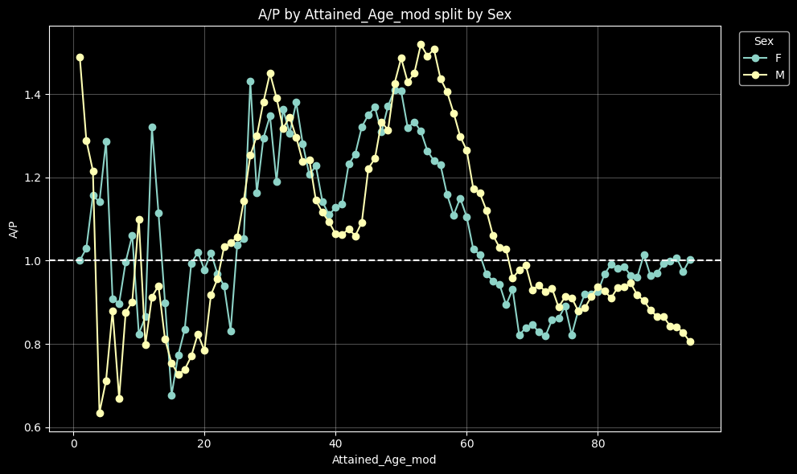
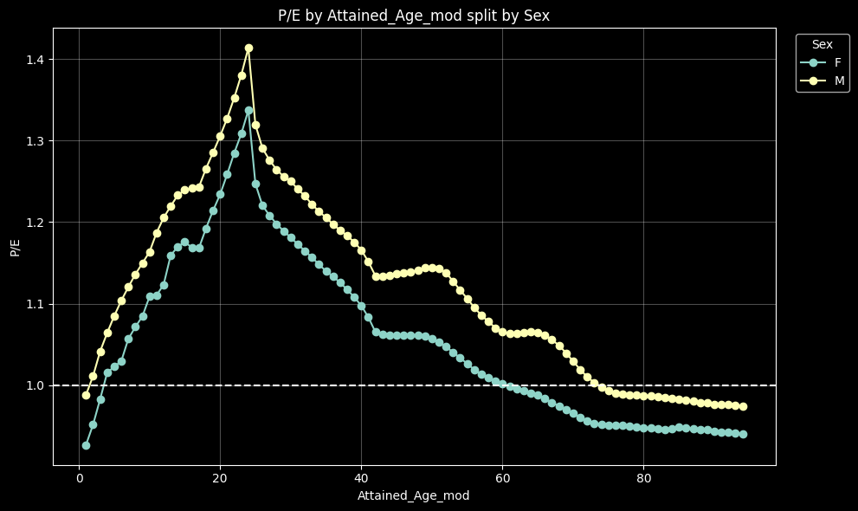

Model 5 — Attained-Age Challenger (poisson_gam_attained)
Replaces Issue_Age_mod_spline with Attained_Age_mod_spline (attained age captures both issue age and duration jointly):
Categorical factors:
- Age_Ind
- Sex
Continuous splines (when ENFORCE_CONTINUITY = True, the default)
- Attained_Age_mod_spline — cubic B-spline with interior knots at [16, 40], bounded [1, 94.5]
- Duration_spline — 1, 14, 25
- Issue_Age_spline — 10
If ENFORCE_CONTINUITY = False (testing mode only), the attained-age spline is replaced by three raw piecewise-linear hinge columns: AA_seg1, AA_seg2, AA_seg3.
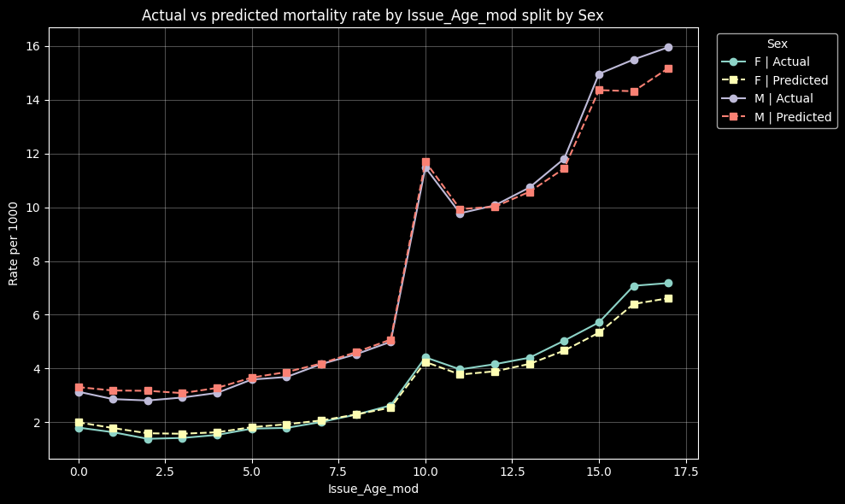
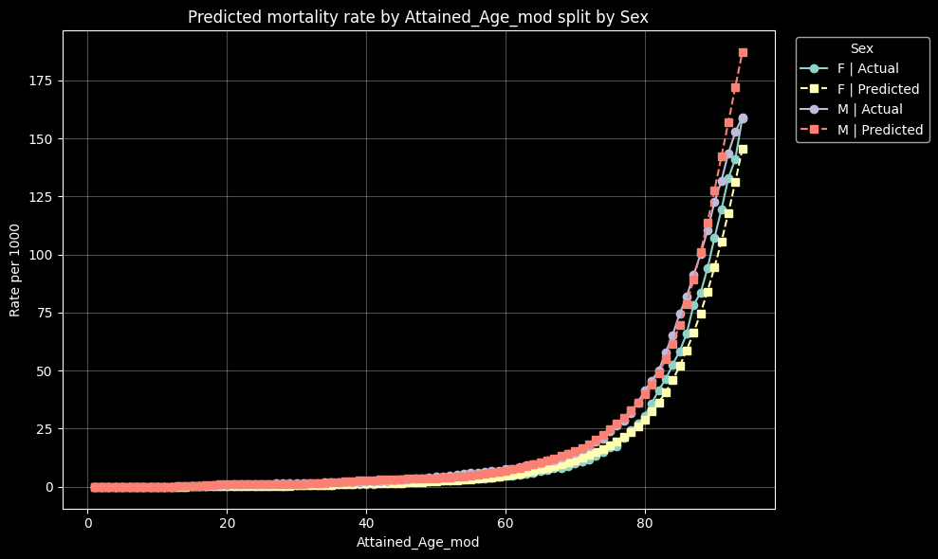
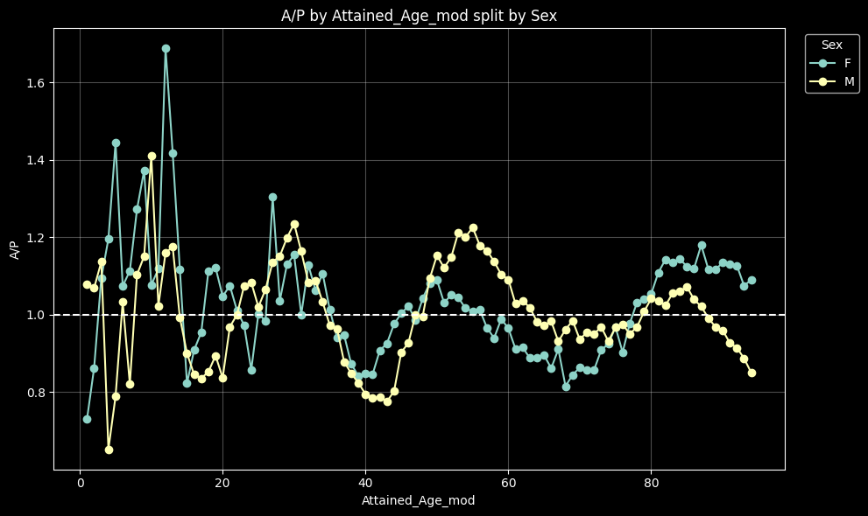
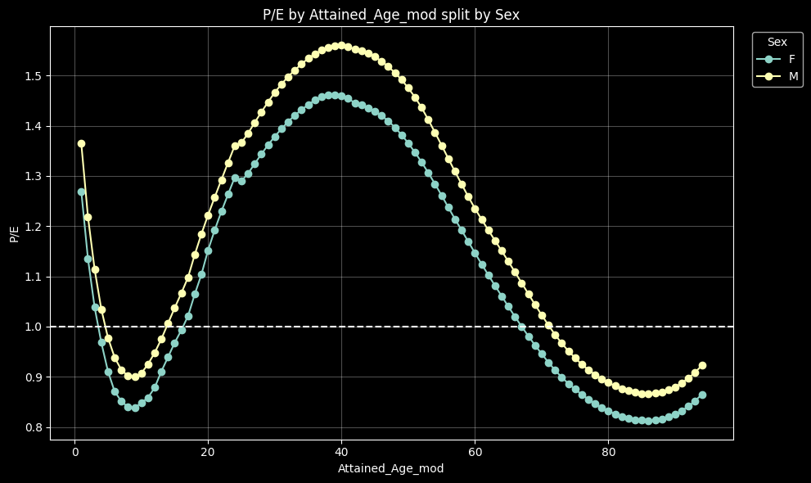

2015 VBT setting:
- Attained_Age_mod_spline — cubic B-spline with interior knots at [35, 45], bounded [1, 94.5]
- Duration_spline — 6
- Issue_Age_spline — /
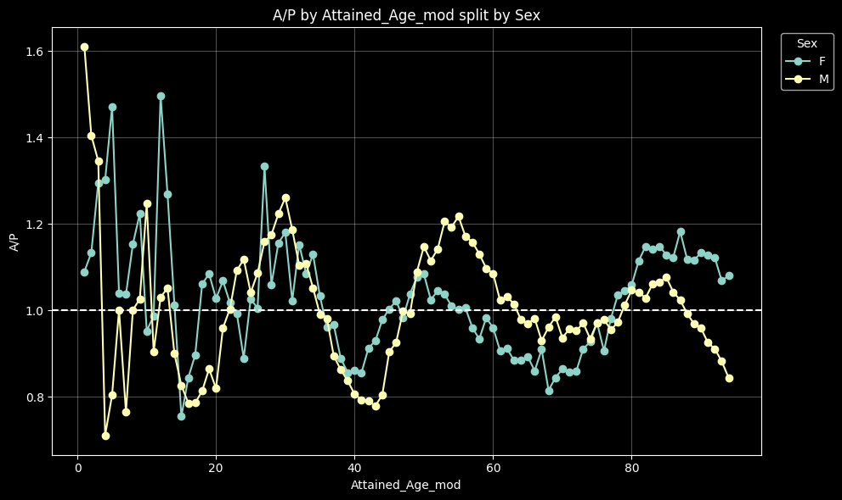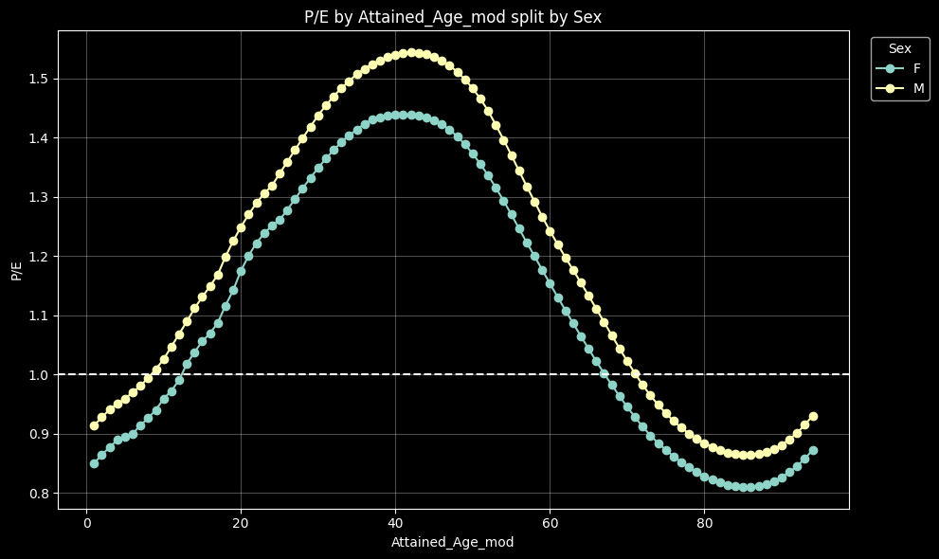

Model 6 — Attained-Age Challenger (poisson_gam_attained)
Replaces Issue_Age_mod_spline with Attained_Age_mod_spline (attained age captures both issue age and duration jointly):
Categorical factors:
- Age_Ind
- Sex
- Insurance_Plan_Group (grouped: Perm / Term / Other)
- Face_Band_Group (grouped: <100k / 100k-999k / 1M+)
